Troubleshooting Notes

Version 1:

Testing to see if Data is correct

Callum J Warwick (CJW) Notes

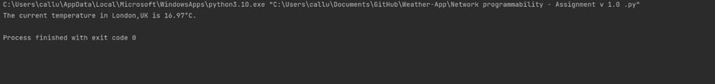

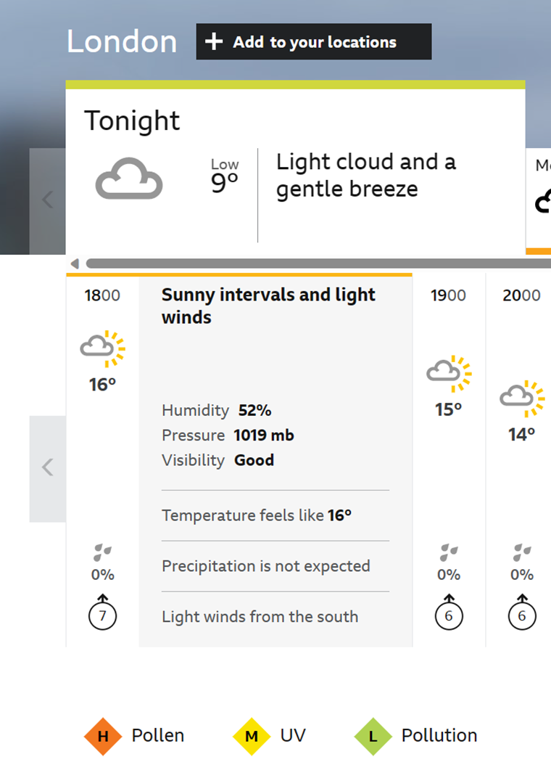

I’ve tested the app temperature with another weather application. And the temperature being pulled from the API appears to be similar to what is being shown on BBC Weather. Which would suggest that the user would get an accurate response from the API.

Not sure how it would work for smaller cities or towns? Maybe this be worth a test.

**Rural locations not being detected – Jonney**

When searching for individual cities or towns within the UK the results are coming back as relatively close to what is shown on other third-party weather applications, a major issue relating to location, is that if you search for a rural area within the API, it unfortunately doesn’t reveal any results  
  
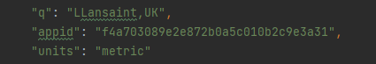  
  
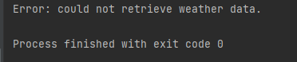

Currently if a user in a rural location is looking to search for the weather in their area and no results are being displayed, the best approach for them as a current work around would be to search for a more highly populated area nearby, which should give the same results. Following version 1 implementation, as a team we have considered that a facility to search for rural/low populated areas will be included as a future release improvement for the app and if there are any complaints regarding its current search functionality, we can either direct the users to going through the workaround as stated above, or we could make some changes to the code to accommodate this.

**Temperature Unit Output issues - Jonney**  
When changing the temperature units within the code from ‘Metric’ to ‘Imperial’, this does reflect within the temperature given result which is what would be provided with Faren height units, but the only issue identified is that the °C label is hard coded into the script  
  
  
  
  
A potential change/fix for this is to simply remove that label from the code where it will return the temperature unit needed when the units variable is adjusted to metric or imperial.